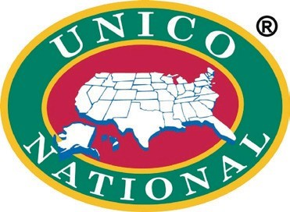
Bloomfield Chapter of UNICO
Juniors only - Intern Application
2021 -2022

Please be sure your application is complete with attachments before submitting to UNICO. Incomplete applications will not be considered.
Deadline: October 1, 2021
Applicants being considered for Internship will be contacted by a member of UNICO to arrange an interview date and time. (Due to COVID school guidelines, if in-person interviews at BHS are not possible other arrangements will be made.)
Questions can be directed to bloomfieldunico@gmail.com

9/10/2021

